**Registering a New User Account for an Existing Service Provider**

**on the Eligible Training Provider List**

It’s very easy!

1. Go to the [Eligible Training Provider List (ETPL)](https://joblink.maine.gov/training)
2. You will see this screen.

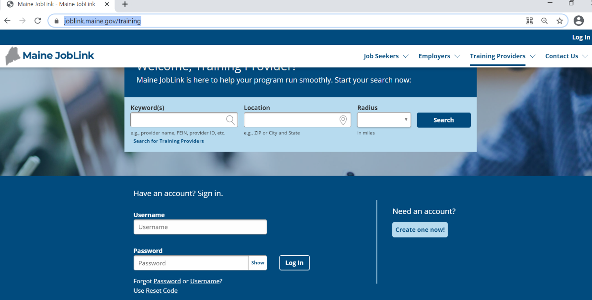

1. Select “Create one now!” You will see this screen.

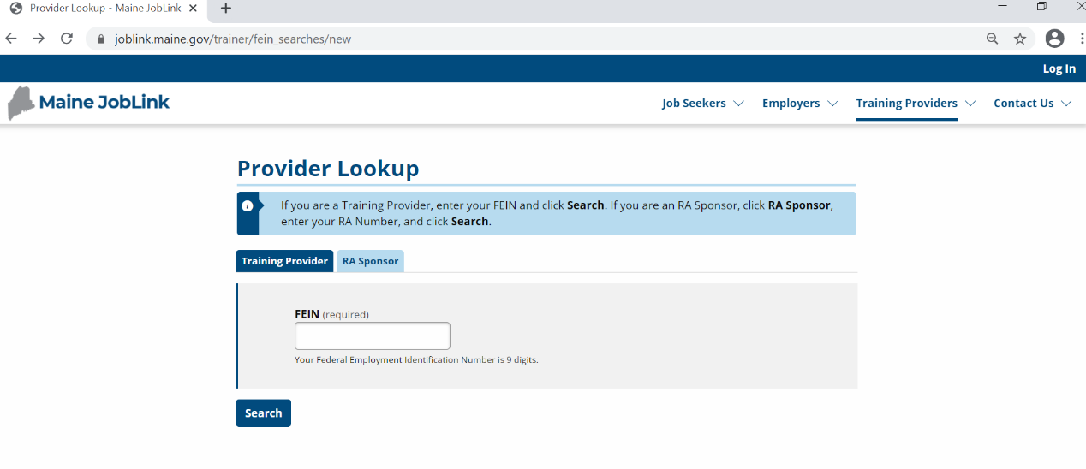

1. Enter your Federal ID Number (FEIN) for your school: XXxxxxxxx
2. Select Search. You will see this screen.

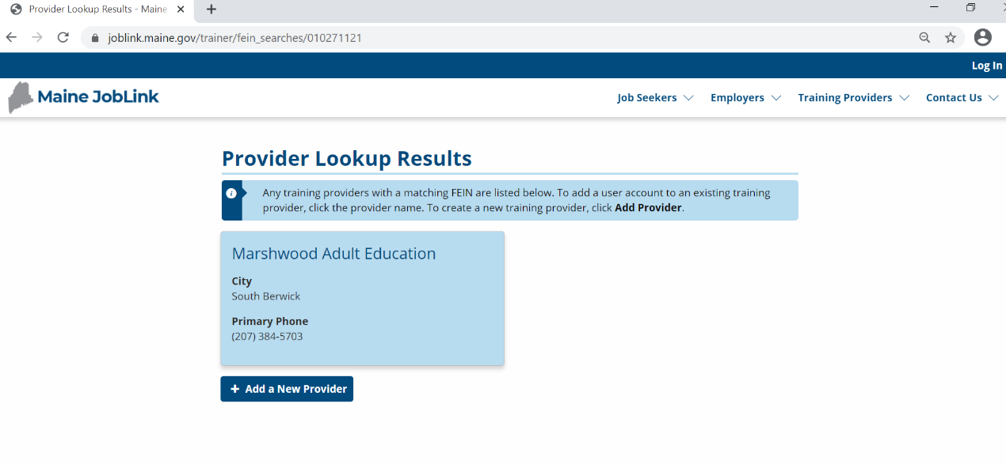

(207) XXX-XXXX

Your School Name

1. Click on your school name. You will see this screen:

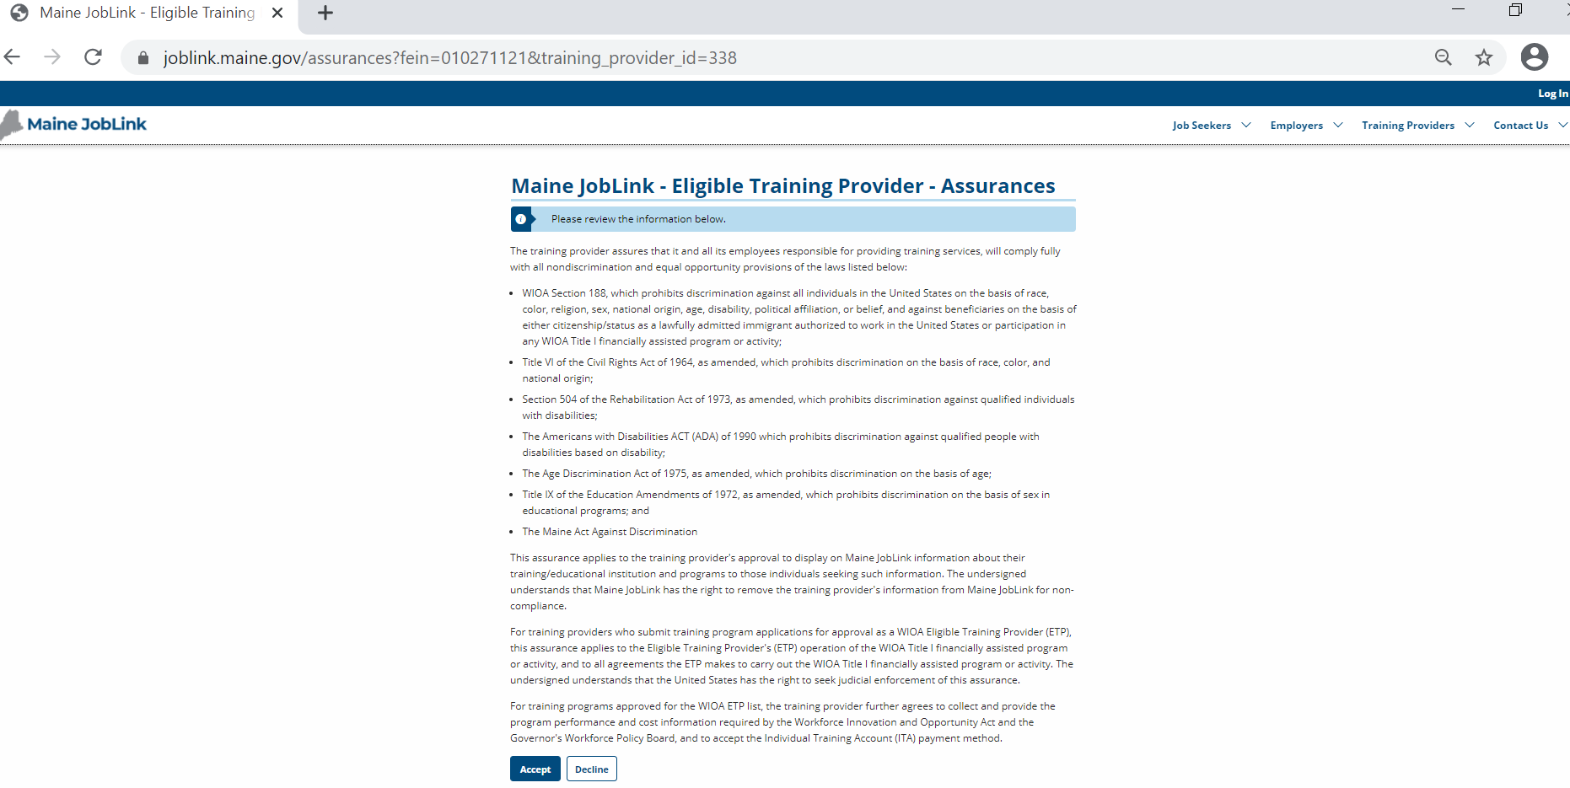

1. Click on Accept. You will see this screen next:

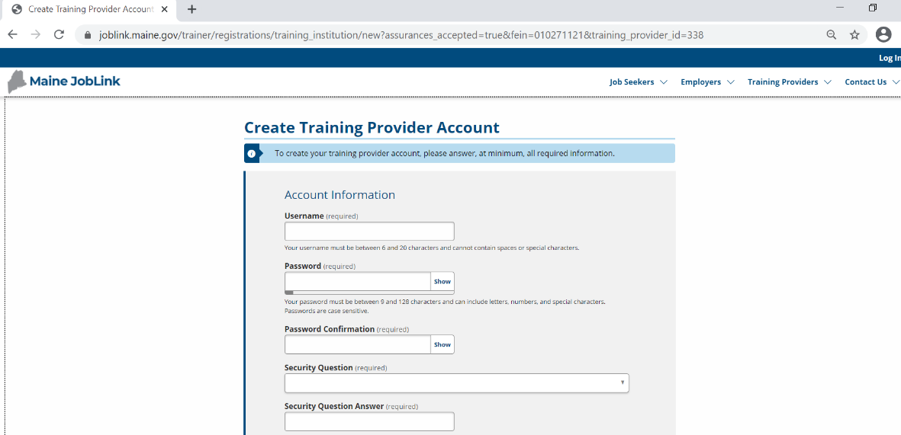

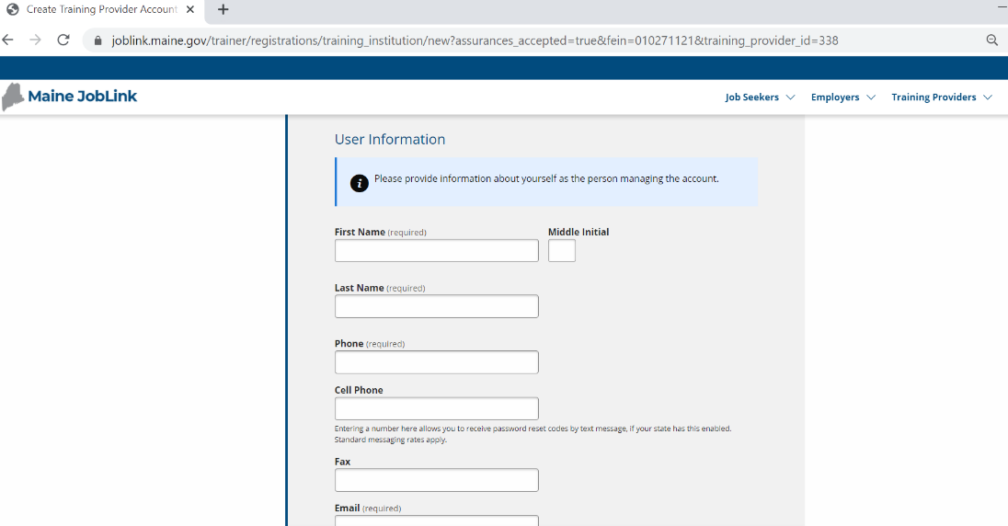

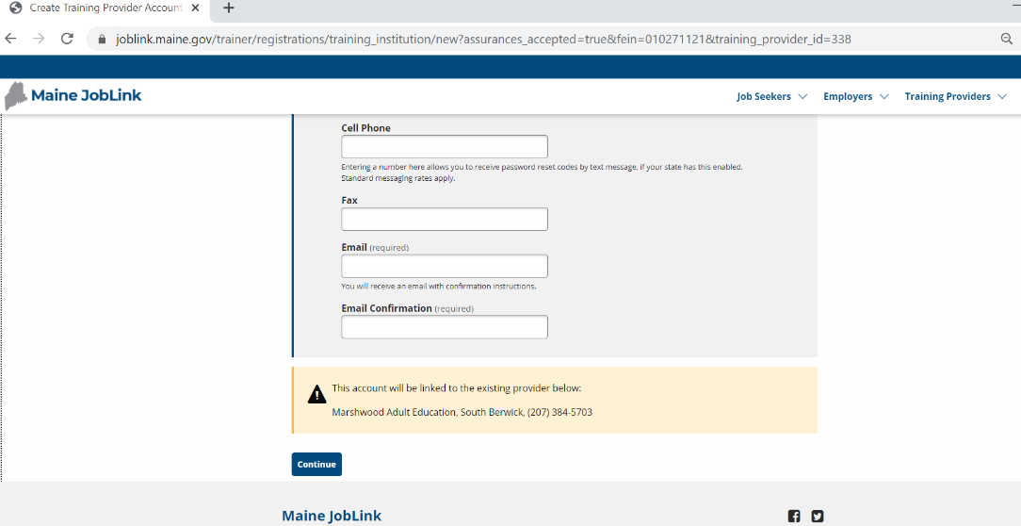

1. Fill out all the fields on the screen. Note that the system says your user account is linked to the school whose FEIN you entered.
2. Hit Continue.
3. You will see this screen.

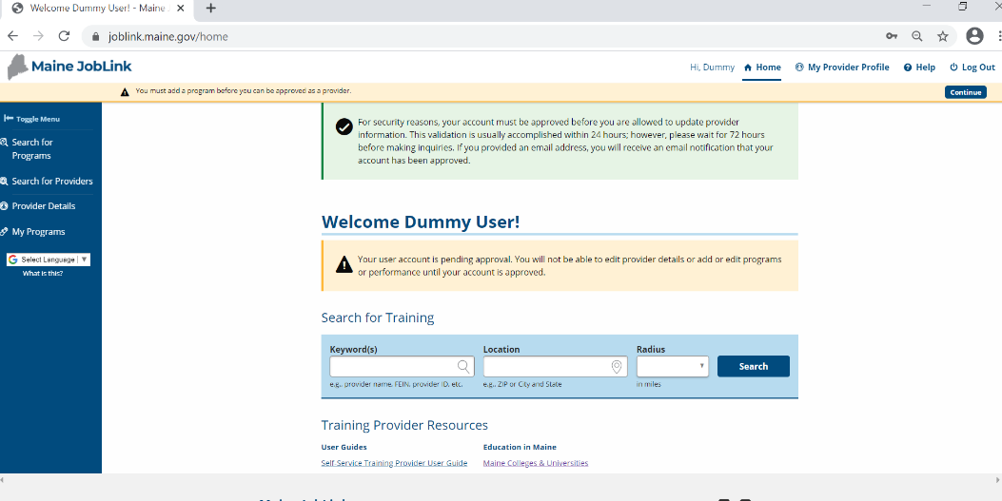

1. You are finished applying for a new user account. In a day or two, your new account will show up on our approval menu. Once approved as a user, you can manage your school’s account on the ETPL.

Questions? Contact [ETPLInfo.Dol@maine.gov](mailto:ETPLInfo.Dol@maine.gov)